**EXERCISE: 05**

**DATE: 20.11.2020**

**AIM:**

To write a python function to print missing characters to make string program

**PROGRAM:**

sentence = input()

sentence = sentence.replace(" ","")

alpha_flag = [0]*26

for char in sentence:

asci = ord(char)-97

alpha_flag[asci]=1

asci=0

for i in range(0, len(alpha_flag)):

if(alpha_flag[i]==0):

asci=i+97

print(chr(asci),end="")

**LINK:**

<http://103.53.53.18/mod/vpl/forms/submissionview.php?id=235&userid=1697>

**OUTPUT:**

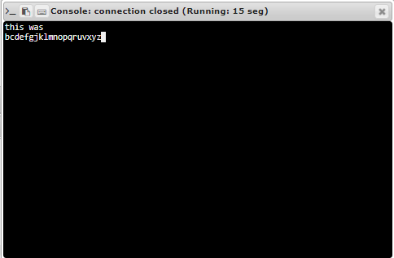

**RESULT:**

Thus the program is executed successfully